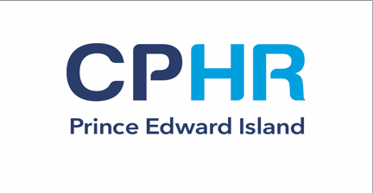
NATIONAL KNOWLEDGE EXAM® (PEI)
REGISTRATION FORM
Please complete and email, fax, or send to us by post.

CHARTERED PROFESSIONAL IN HUMAN RESOURCES - NATIONAL KNOWLEDGE EXAM

The National Knowledge Exam® (NKE) assesses your understanding of HR knowledge and skills. After you have passed the exam, you are considered a candidate for certification.
Registration Deadline: March 25th 2020 / Exam Date: May 29th 2020 / Exam Fee: $525+HST
Completing this registration form confirms your application to write the May 29th 2020 NKE® exam.

REGISTRANT DETAILS

Title: Mr. ◻ Mrs. ◻ Ms. ◻ Dr.◻ Other:

First Name: Job Title: Phone Number:
Business/Work Address:
Last Name: Organization: Email:

Language preference for NKE: English ____ French ____

Special Accommodations If you require any special accommodations as it pertains to writing the NKE, please provide a description below:

EDUCATIONAL REQUIREMENT (if applicable for pathway)

Name of Educational Institution: ________________________________________________
Title of Bachelor Degree Obtained: ________________________________________________
Year of Completion: ________________________________________________
Registrant Signature: ________________________________________________
I attest that my education credentials are valid and complete.

PAYMENT DETAILS

PAYMENT BY CREDIT – Please use this form to pay by or
Cardholders Name (as it appears on the card)

Billing Address:

Card Number Expiry Date

CVV Number {last 3 digits on back of credit card}

Cardholder Signature
Your signature on this form authorizes us to charge the current fees to your card.

REQUEST PAYMENT BY INVOICE INSTEAD  (Check if applicable only) Note: Payment must be received by registration deadline.

RETURNING THE FORM

Send the form by email to: main@cphrpei.ca
Or by post to: CPHR PEI, 101 Kent Street PO Box 2151 Charlottetown, Prince Edward Island C1A 8B9

